The Ohio State University

Colleges of the Arts and Sciences New Course Request

Department of Geological Sciences

Academic Unit
Geological Sciences

Book 3 Listing (e.g., Portuguese)
310 Earth Systems Data Collection and Analysis
Number Title
Data Coll & Analysis U 05
18-Character Title Abbreviation Level Credit Hours

Summer Autumn X Winter Spring Year 2006
Proposed effective date, choose one quarter and put an “X” after it; and fill in the year. See the OAA curriculum manual for deadlines.

A. Course Offerings Bulletin Information

Follow the instructions in the OAA curriculum manual. If this is a course with decimal subdivisions, then use one New Course Request form for the generic information that will apply to all subdivisions; and use separate forms for each new decimal subdivision, including on each form the information that is unique to that subdivision. If the course offered is less than a quarter or a term, please complete the Flexibly Scheduled/Off Campus/Workshop Request form.

Description (not to exceed 25 words): This course is designed to provide an introduction to the basic

competencies in observation of earth systems, image interpretation, and software integration.

Quarter offered: Autumn Distribution of class time/contact hours: 3, 1-hr classes; 1, 3-hr lab
Quarter and contact/class time hours information should be omitted from Book 3 publication (yes or no): No

Prerequisite(s): GEC data analysis course; sophomore standing and above

Exclusion or limiting clause:

Repeatable to a maximum of __NA___ credit hours.

Cross-listed with:

Grade Option (Please check): Letter X S/U Progress What is course is last in the series? ______

Honors Statement: Yes No X GEC: Yes No X Admission Condition
Off-Campus: Yes No X EM: Yes No X Course: Yes No X

Other General Course Information:
(e.g. “Taught in English.” “Credit does not count toward BSBA degree.”)

B. General Information

Subject Code________________________ Subsidy Level (V, G, T, B, M, D, or P)___________________________
If you have questions, please email Jed Dickhaut at dickhaut.1@osu.edu.

1. Provide the rationale for proposing this course:
See Attached

2. Please list Majors/Minors affected by the creation of this new course. Attach revisions of all affected programs. This course is (check one): Required on major(s)/minor(s) X A choice on major(s)/minors(s)
An elective within major(s)/minor(s) A general elective:

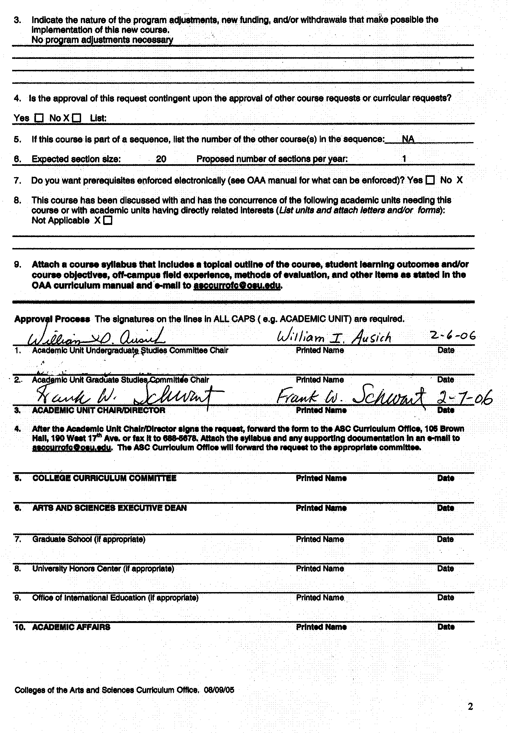

Dept of Geological Sciences 310

Earth Systems Data Collection and Analysis

Rationale: In the past, the only way geologists had to investigate the Earth was through direct observation and sampling on the ground, and from ships and aircraft. Observations were mainly limited to those features that could be seen, photographed, or measured in the visible portions of the spectrum. Consequently, it was difficult if not impossible to obtain global interpretations or to document changing conditions over large areas. Today, a geoscientist must be knowledgeable and proficient in a variety of methodologies for remote data collection and analysis techniques in order to successfully evaluate and understand the complex array of available earth systems data. Remotely sensed and photogrammetric data are readily accessible in a variety of formats and are commonly utilized in order to develop a better understanding of the complex interrelationships of earth systems (atmosphere, hydrosphere, geosphere, and biosphere). Remote sensing integrated with powerful software technologies is now the approach of choice for mapping physical settings, regional resources and hydrological analyses, and global atmospheric and ocean phenomena.
The proposed course is necessary to develop and strengthen the basic data collection and analytical skills of geological sciences undergraduate majors. Constantly changing technological advances have mandated an early competency in these methodologies to ensure academic and post-graduation success in the geosciences. Additionally, students outside the geological sciences will benefit from this introductory-level course through an increased awareness of the increasingly prevalent investigative techniques that complement many of today’s scientific and non-scientific investigations. It is anticipated that enrollment for this course will grow steadily from less than 10, to 20 or more with increasing departmental and university exposure.

NEW COURSE SYLLABUS

College of the Arts and Sciences
Department of Geological Sciences
Course Number/Title: 310 Earth Systems Data Collection and Analysis

Instructor/Lectures: Dr. Doug Alsdorf

Graduate Teaching Associate: TBD

Required Text/Reading List: TBD

Credit: 5 Credit Hours

Prerequisite: GEC data analysis course; sophomore standing and above

Course Structure: Three, 1-hour lecture/demonstration periods and one 3-hour lab/wk

Description: This course is designed to provide an introduction to the basic competencies in observation of earth systems, image interpretation, and software integration.

Content: This course emphasizes both theory and applications. Students will not only learn scientific and technical theory and issues, but be expected to put these issues into practice and become proficient in the handling and processing of remotely sensed and photogrammetric data. As a result, laboratory work focused on case studies and problems will be a major course component, reflected in the overall assessment.
Emphasis in this course will be on the introduction to the different platforms and sensors used in remote sensing; presentation of the underlying principles of acquiring and interpreting data from imaging systems covering the spectrum from ultraviolet through microwave; and use of integrative computer modeling and mapping/GIS analysis tools such as ERDAS and ArcView. Finally, and most importantly, this course will examine the application of remote sensing and photogrammetry in geologic and hydrologic assessments.

Course Objectives: The overall objectives of this course will be to develop the fundamentals of remote sensing and photogrammetry, to present basic image processing and software techniques, and to demonstrate present geologic and hydrologic applications of the technologies.

Specifically, upon the successful completion of the course, students will understand (i) uses of various platforms (airborne, satellite, telemetry) in practice; (ii) the basics of projections, datums,
and coordinate systems as applied to construction of DEMs, (iii) characteristics of various remote sensing instruments/sensors and their utility for various application; (iv) the basic application of software for digital image processing and analysis; interpretations and the integration in a GIS setting; (v) skills such as how to download and adapt data sets from various global, regional, and local portals; and (vi) applications of remote sensing and photogrammetry in geologic and hydrologic assessments.

Course Grades: The course will be graded according to results from examinations and laboratories, as follows:

Lab Assignments 30%
Team Projects 20%
Final Exam 50%.

Policies on Attendance and Absences: Attendance is required at all lecture sessions. Professor Alsdorf should be notified as soon as possible in emergency situations where students must miss class. The deadline for make-up work for missed assignments, quizzes or examinations is one (1) week from the original date of administration. Each student must meet individually with Dr. Alsdorf regarding make-up work for missed assignments.

Disability Services: Students with disabilities that have been certified by the Office for Disability Services will be appropriately accommodated, and should inform the instructor as soon as possible of their needs. The Office for Disability Services is located in 150 Pomerene Hall, 1760 Neil Avenue (telephone 292-3307, TDD 292-0901, http://www.ods.ohio-state.edu/).

Academic Misconduct: The Ohio State University and the Committee on Academic Misconduct (COAM) expect that all students will complete all academic and scholarly assignments with fairness and honesty. Failure to follow the rules and guidelines established in the University’s Code of Student Conduct and this syllabus may constitute “Academic Misconduct”.
The Ohio State University’s Code of Student Conduct (Section 3335-23-04) defines academic misconduct as: “Any activity that tends to compromise the academic integrity of the University, or subvert the educational process”. Examples of academic misconduct include (but are not limited to) plagiarism, collusion (unauthorized collaboration), copying the work of another student, and possession of unauthorized materials during an examination. All suspected cases of academic misconduct will be reported to the University Committee on Academic Misconduct. If academic misconduct has been committed, possible sanctions could include a failing grade in this course and suspension or dismissal from the University.

Topical Outline: The following is a tentative, chronological outline of course lecture and associated laboratory topics:

- Course overview, including introduction to remote sensing and interpretation previews of important earth-science problems that will be addressed

Laboratory 1.1: Using the NASA World Wind Program for exploring important world problems

- Introduction to mapping of the earth’s surface form using digital data products; including overview of DEMs, datums and datum conversions, USGS DEM products, SRTM data and data, and Lidar for detailed terrain assessment

- Introduction to geographic information systems and basic data availability

Laboratory 3.1: Introduction to ArcView – Tutorials

- History and description of common remote sensing platforms and sensors; including features of the electromagnetic spectrum, atmospheric and surface interactions, and basic terminology for satellite measurements (pixel, resolution, nadir, azimuth, viewing angle, swath, etc.); Landsat family of satellites used in the investigation of climate, geologic setting, and hydrologic issues related to prairie pothole lakes; and new sensors for evaluation of geological problems, including multispectral data for water quality and interferometric SAR for surface change analysis

Laboratory 4.1: Introduction to Waubay Lakes issues, including review of pertinent literature, websites, and exploration of key issues using Landsat

Laboratory 4.2: Exploring new satellite data

- Site assessment based on digital and analog photogrammetry; including types of data products and analog and digital formats; and identification and mapping of landforms and site history through retrospective analysis

Laboratory 5.1: Aerial photograph acquisition – dataset sources and downloads

